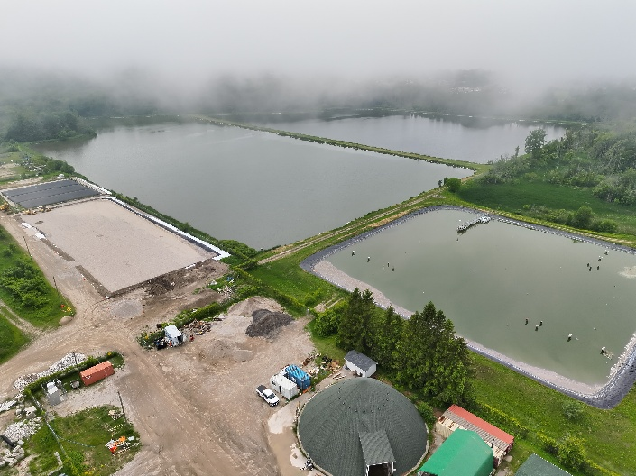
Lagoon Sludge Removal Project
Frequently Asked Questions (July 2, 2026)
The Municipality recognizes that odours associated with the Lagoon Sludge Removal Project have been disruptive for nearby residents. While the work is necessary to restore the wastewater treatment system, staff understand the inconvenience the project has created and appreciate the patience of affected residents. The following questions address many of the concerns raised by the community.
- Why is this project necessary?
A 2024 engineering assessment identified significant sludge accumulation within the lagoon system. The accumulated material is reducing treatment capacity and impacting long-term system performance. Removing the sludge is necessary to restore capacity, improve reliability, support regulatory compliance, and maintain wastewater services for the community.
- Is the air quality being monitored?
Municipal staff conduct air monitoring as part of the project's operational and worker safety requirements. Monitoring completed to date has not identified conditions indicating a risk to public health. Staff continue to monitor conditions throughout the project and will respond appropriately if conditions change.
- Are the odours harmful to health?
The odours can be unpleasant and may interfere with normal outdoor activities; however, based on monitoring completed to date and information available to the Municipality, there is no indication that the odours present a risk to public health. If monitoring or regulatory agencies identify a public health concern, the Municipality will immediately advise residents and take appropriate action.
- Will monitoring information be made available to the public?
The Municipality is reviewing what monitoring information can be shared during the project. Annual compliance reports are already publicly available through the Municipal website, and staff will provide additional project information where practical and appropriate.
- How can residents report concerns?
Residents are encouraged to contact the Municipality directly through Environmental Services when they experience concerns related to odours or project activities. Resident feedback helps staff monitor conditions and evaluate mitigation measures.
- Is the Ministry aware of the project and resident concerns?
Yes. Provincial and Federal regulatory agencies are aware of the ongoing lagoon improvement work and the Municipality's efforts to restore treatment capacity and improve system performance.
- Will inspection results be shared publicly?
Where inspection findings, reports, or regulatory correspondence are available for public release, the Municipality will review opportunities to share information through the project webpage and Council reporting.
- Why is sludge removal taking place during the summer months?
Sludge removal is most effective during warmer months when lagoon flows are at their lowest. Allowing operation flexibility for treatment processes to operate efficiently and allow staff the best opportunity to capture sludge. The work must also be coordinated with wastewater treatment operations, contractor availability, regulatory requirements, and environmental conditions. Completing the work during this period provides the best opportunity to remove accumulated sludge efficiently while maintaining wastewater treatment services.
- Were there alternative work schedules or seasons considered?
The Municipality evaluated a range of operational approaches as part of project planning. Factors considered included treatment performance, environmental conditions, contractor availability, worker safety, odour impacts, and overall project costs.
At this time, summer operations remain the most practical and effective approach for completing the work while maintaining wastewater treatment services.
- Can the project timeline be shortened by adding night shifts?
The Municipality has considered opportunities to accelerate the project; however, extending work into evenings or overnight periods would require consideration of contractor resources, equipment availability, operational requirements, costs, worker safety, and potential noise impacts to nearby residents.
The current schedule reflects the approach determined to be the most effective and practical for the project.
- What is being done to reduce odours?
Municipal staff and project partners are actively working to reduce odours where possible. Measures include operational adjustments, ongoing monitoring of lagoon conditions, and evaluation of additional treatment options. Staff continue to work with engineers and contractors to identify opportunities for improvement.
- Are chemical odour neutralizers being used?
The Municipality has reviewed commercially available odour-control products. Not all products are appropriate for wastewater treatment systems, and any product used must be compatible with treatment processes and regulatory requirements. Staff continue to evaluate available options and will implement additional measures where they are demonstrated to be safe and effective.
- What happens if odour levels become stronger?
If odour conditions become more significant, staff investigate operational conditions, review weather and treatment activities, and determine whether additional mitigation measures or operational adjustments can be implemented. Resident reports are an important part of this process.
- Why do odours sometimes occur on cooler or rainy days?
Odours are influenced by more than temperature alone. Wind direction, humidity, atmospheric pressure, rainfall, and changing biological conditions within the lagoons can all affect how odours are experienced in surrounding neighbourhoods. As a result, odours may occasionally be noticeable even during cooler weather.
- Will residents receive notice about upcoming work?
The Municipality recognizes the importance of timely communication. Project updates, anticipated work schedules, and operational notices will continue to be shared whenever possible through the project webpage, news releases, and social media channels. Where practical, the Municipality will provide advance notice of work that may result in increased odours. Because wastewater treatment operations are influenced by weather and operational conditions, schedules may occasionally change with limited notice.
- What is the long-term plan for the wastewater treatment system?
The Municipality has begun long-range planning for the future of wastewater treatment services. Staff will work with engineering consultants and Council to evaluate future treatment options, infrastructure needs, and long-term investments required to support community growth. The current sludge removal project is an important first step in restoring the existing system.
- How will preventative maintenance be handled in the future?
The Municipality is committed to proactive asset management and preventative maintenance practices to help avoid significant future accumulations. Future maintenance schedules will be informed by operational monitoring, engineering recommendations, and regulatory requirements.
- Will the Municipality provide compensation, tax relief, or fee reductions due to odour impacts?
At this time, the Municipality has not established a compensation, tax relief, or utility credit program related to temporary odours associated with the sludge removal project. The project is necessary to restore the wastewater treatment system and protect long-term service reliability. The Municipality remains focused on completing the work as efficiently as possible while continuing to implement measures to reduce impacts on nearby residents.
- Where do I obtain updates?
www.kincardine.ca/Sludge-Removal-Project

